Downloading...
From: https://drive.google.com/uc?id=1VJaDVtDUtKQMmhRAqr3t-fgng899ZdRV
To: /content/Python Application Usage Log Data Set.xlsx
100%|██████████| 1.68M/1.68M [00:00<00:00, 54.3MB/s]
INFO:prophet:Making 28 forecasts with cutoffs between 2017-09-08 00:00:00 and 2024-05-04 00:00:00
100%
28/28 [00:05<00:00, 3.75it/s]
[Grid 1] completed with cfg={'changepoint_prior_scale': 0.2, 'seasonality_prior_scale': 10, 'regressor_prior_scale': 0.5} (CV rows=1460)
INFO:prophet:Making 28 forecasts with cutoffs between 2017-09-08 00:00:00 and 2024-05-04 00:00:00
100%
28/28 [00:09<00:00, 2.21it/s]
[Grid 2] completed with cfg={'changepoint_prior_scale': 0.5, 'seasonality_prior_scale': 10, 'regressor_prior_scale': 1.0} (CV rows=1460)
INFO:prophet:Making 28 forecasts with cutoffs between 2017-09-08 00:00:00 and 2024-05-04 00:00:00
100%
28/28 [00:13<00:00, 1.71it/s]
[Grid 3] completed with cfg={'changepoint_prior_scale': 1.0, 'seasonality_prior_scale': 15, 'regressor_prior_scale': 1.0} (CV rows=1460)

Selected config: {'changepoint_prior_scale': 0.2, 'seasonality_prior_scale': 10, 'regressor_prior_scale': 0.5}
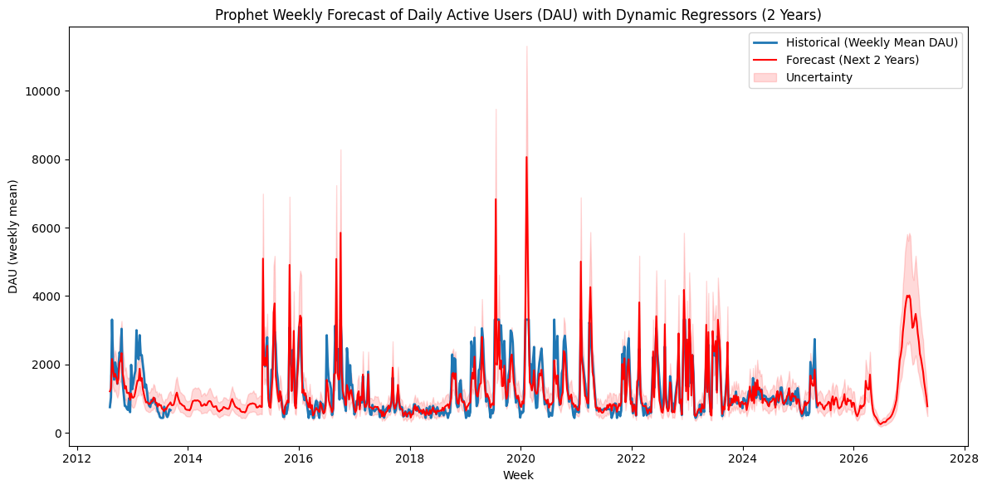
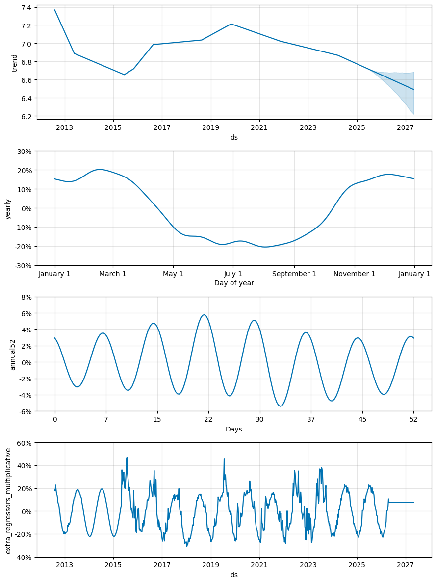

=== Prophet Cross-Validation Accuracy (original DAU scale) ===
Accuracy (100 - MAPE): 62.60%
MAPE: 37.40% sMAPE: 41.67%
MAE: 474.533 RMSE: 888.112 R²: -0.297
MASE (vs naive-1): 1.197
Directional Accuracy: 69.66%
ds yhat_inv yhat_lower_inv yhat_upper_inv
762 2027-03-14 2307.509629 1508.496946 3466.267396
763 2027-03-21 2172.026051 1368.050860 3271.514262
764 2027-03-28 1979.869894 1275.646263 2906.276463
765 2027-04-04 1783.069575 1113.903465 2713.730095
766 2027-04-11 1483.879585 929.886266 2181.535989
767 2027-04-18 1269.351031 810.871535 1875.856200
768 2027-04-25 1052.859719 671.431849 1562.930729
769 2027-05-02 775.310254 486.146902 1131.327531

